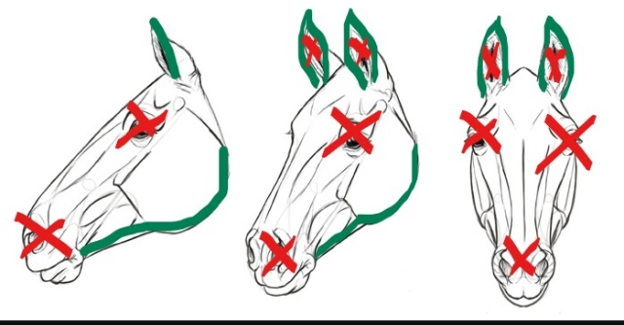



**Acceptable to trim**

X **Not acceptable to trim**



**The period of the 1 August 2021 – 31 December 2021, will be used as an educational period. If any horse or pony is noted to have had whiskers, eyes or ears trimmed, the exhibitor or competitor can be given a copy of the RAS whisker & ear trimming pamphlet for educational purposes, and to bring their attention to the upcoming ban on this. Any horse or pony that has already been trimmed over winter, can use the period until 31st December 2021 as a “regrowth period”, as whiskers and inner ear hair take time to regrow.**

**RAS Equestrian Rule – GR. 6**

* The Royal Agricultural Society (RAS) has teamed with Equestrian Sports New Zealand (ESNZ) and NZ Pony Club (and the FEI from 2021) and banned the trimming of whiskers, eye and inner ear hair for horses and ponies competing at affiliated A&P Shows and Kindred Events from the 1 January 2022.
* RAS rules state GR6 Abuse of Exhibits b) Abuse can be defined as intentionally acting in a way, which may cause pain or unnecessary discomfort to a horse.
* RAS further considers other examples of abuse (but not limited to): whip or beat an exhibit excessively; subject an exhibit to any kind of electric shock device; excessive or persistent use of spurs; or to jab the exhibit in the mouth with the bit; remount or attempt to remount an obviously exhausted, lame or injured exhibit; rap an exhibit anywhere in or outside the grounds of the event; hyper sensitise any part of an exhibit; leave exhibit without adequate food, drink and exercise.
* Any person witnessing any form of abuse should utilise the RAS Resolution Process. For the purposes of this matter - illegal trimming of whiskers, eye or inner ear hair – from 1 January 2022 a protest form should be filed with the affiliated A&P Show/Kindred Event, citing the rule broken as being GR6 b. All affiliated Shows & Events have a template protest form available through the RAS Resolution Process which can be found here: <https://www.ras.org.nz/wp-content/uploads/2018/08/RAS-Resolution-Process-updated-2018.doc.pdf.>
* From the 1 January 2022, any upheld protests regarding the matter of whisker, eye & inner ear trimming should be handled in the following manner:
* The exhibitor/competitor is to be given a copy of the RAS whisker, eye & ear trimming pamphlet for educational purposes.
* The exhibitor/competitor and horse/pony are to be asked to leave the show ring
* Any prizes, ribbons and/or placings are to be forfeited.
* Please note all RAS Equestrian Judges will be advised, when judging, they are not to discriminate against facial whiskers and hair.
* Full RAS Equestrian Rules and Regulations can be found here: <https://www.ras.org.nz/wp-content/uploads/2019/07/RAS-Rulebook-2019-FULL.pdf>

* Horses have whiskers on their face around their eyes and muzzle (nose and lips). In these locations whiskers not only help protect delicate tissue, but also help compensate for the blind spots a horse has in front of its face and underneath its nose.
* A horse’s whiskers (called vibrissae) are actually an incredibly important sense to them. The whiskers around the eyes and muzzle are extremely sensitive and have a rich nerve supply.
* Ear hair serves a few special functions: to protect the inner ear skin from bugs, sun, and foreign objects. The outer edge of the ear also grows some hair, and in some cases, it can get pretty wild.
* With ears you can find a happy medium – clip the edges of the ear by folding it like a taco and zipping your clippers down the outside of the ear. Leave the insides

**X**

**X**

**INFORMATION AROUND  
WHISKER, EYE & EAR TRIMMING AT RAS AFFILIATED A&P SHOWS & EVENTS**

**From 1 January 2022, the trimming of a horse/pony’s whiskers, eye and inner ear hair is banned for any horses/ponies exhibiting or competing at affiliated A&P Shows or Kindred Events.**